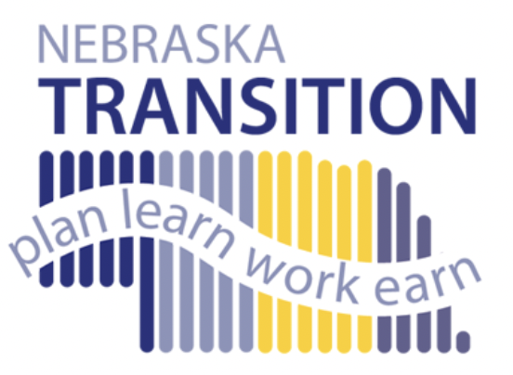
Parent Transition Series
2024-2025

Hosted by the Statewide
Region Transition Facilitators

Zoom Time: 6-7:30 PM CST

Master file of resources located here
08/27/2024  Overview of Transition  Zoom link here  Resources available here  Coordinated by Michalla Schartz, Amy Slama, and Whitney Fagan  michalla.schartz@esu6.org  aslama@esu7.org | 09/24/2024  It’s Never too Early to Think Transition!  Zoom link here  Resources available here  Coordinated by Amy Slama  aslama@esu7.org
10/29/2024  College Supports and Services  Zoom link here  Resources available here  Coordinated by Blair Ryan  bryan@esu10.org | 11/19/2024  Enable/Special Needs Trusts  Zoom link here  Resources available here  Coordinated by Whitney Fagan  wfagan@esu3.org
1/28/2025  Guardianship/Supported Decision- Making  Zoom link here  Resources available here  Coordinated by Diane Reinhardt  dreinhardt@esu13.org | 2/18/2025  Benefits Analysis  Zoom link here  Resources available here  Coordinated by Diane Reinhardt  dreinhardt@esu13.org
3/25/2025  Talking to your Teen about their Disability  Zoom link here  Resources available here  Coordinated by Michalla Schartz  michalla.schartz@esu6.org | 4/29/2025  SSI/Medicaid Benefits - Great New Info!  Zoom link here  Resources available here  Coordinated by Michalla Schartz and Amy Slama  michalla.schartz@esu6.org  aslama@esu7.org

